### **Responsive E-Commerce Website Custom Image Creation and Hosting on Amazon Linux**

#### 

#### **Objective**

The goal of this project is to create a responsive e-commerce website using Amazon Linux, Docker, and Kubernetes, and to integrate it with various AWS services like S3, ECR, and EKS. The website will be deployed on an EKS cluster, utilizing NGINX as a web server, and will be accessible via a Load Balancer.



**Architecture Flow**

1. **Amazon Linux**: Create a Dockerfile and project directory containing index.html and other necessary assets.
2. **AWS S3**: Store website images in an S3 bucket, replacing the URLs in the index.html file to point to S3-hosted images.
3. **Docker**: Build a custom Docker image using the Dockerfile and push it to Amazon ECR.
4. **Amazon ECR**: Store the custom Docker image.
5. **Amazon EKS**: Deploy the Docker image on an EKS cluster with EC2 instances.
6. **NGINX**: Use NGINX for web serving, deploying it via Kubernetes manifests.
7. **Load Balancer**: Expose the website through a Load Balancer and access it via a public URL.

#### **Detailed Steps**

##### **1. Setting Up the Project on Amazon Linux**

* Launch an EC2 instance using Amazon Linux.

Install Docker and necessary tools:

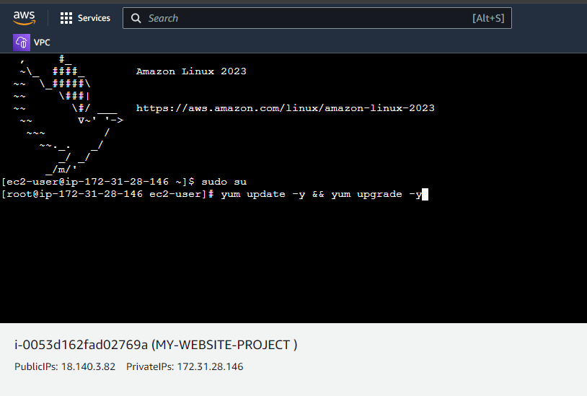

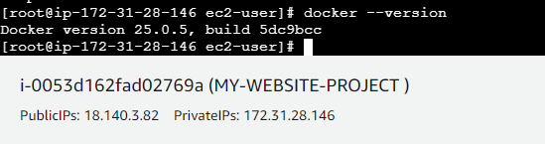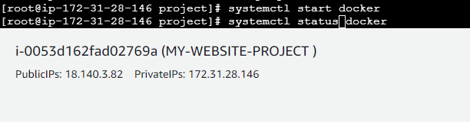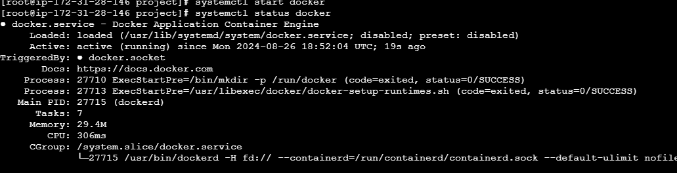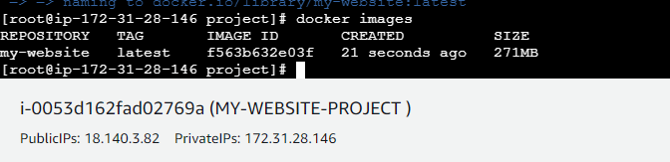

* Create a project directory:

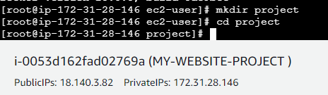

* Create index.html with your e-commerce content, ensuring images are linked to S3 URLs.

##### **2. Uploading Images to S3**

* Create an S3 bucket via the AWS Management Console.
* Upload your website images to the S3 bucket.
* Modify the index.html file to replace image paths with S3 URLs.

##### **3. Creating a Dockerfile**

In the project directory, create a Dockerfile:

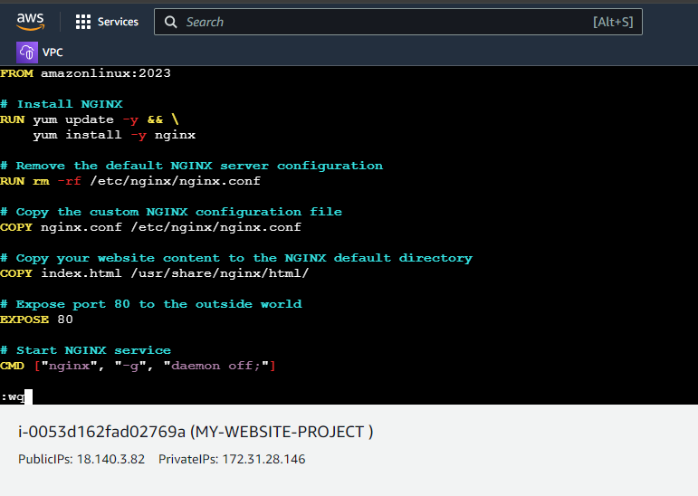

Build the Docker image:  
bash  
docker build -t my-website .

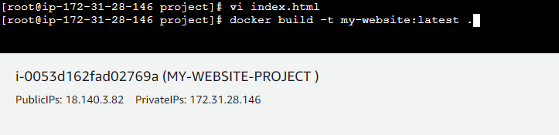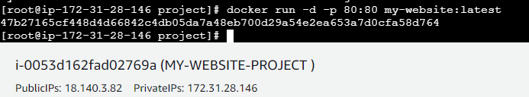

Test the public container using public ip

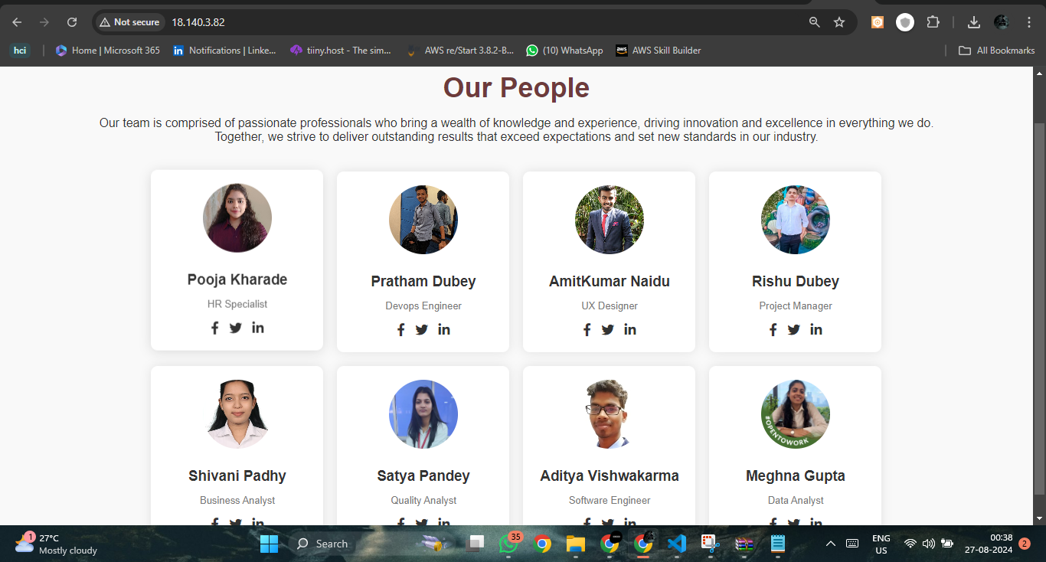

##### **4. Pushing the Docker Image to Amazon ECR**

Authenticate Docker to your ECR registry:  
aws ecr get-login-password --region <region> | docker login --username AWS --password-stdin <account_id>.dkr.ecr.<region>.amazonaws.com

* Create a repository in ECR via the AWS Management Console.

Tag and push your Docker image:  
**bash**  
  
docker tag ecommerce-website:latest <account_id>.dkr.ecr.<region>.amazonaws.com/my-website:latest

docker push <account_id>.dkr.ecr.<region>.amazonaws.com/my-website:latest

##### **5. Creating an Amazon EKS Cluster**

* Create an IAM role for EKS and EC2 instances with the necessary permissions.
* Create an EKS cluster via the AWS Management Console.
* Create a node group for the cluster with the EC2 instances.

##### **6. Deploying on EKS Using kubectl**

* Install kubectl on your Windows machine.

Update the kubeconfig file to point to your EKS cluster:  
bash  
Copy code  
aws eks --region <region> update-kubeconfig --name <cluster_name>

* Create a Kubernetes deployment and service YAML files for NGINX.

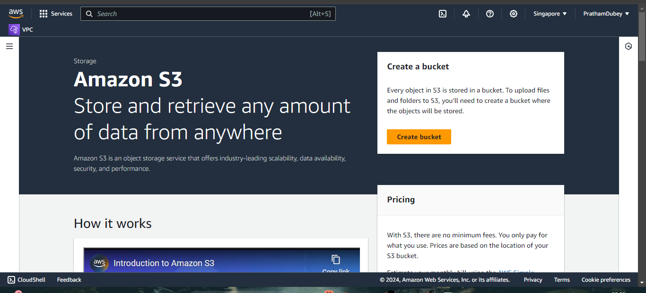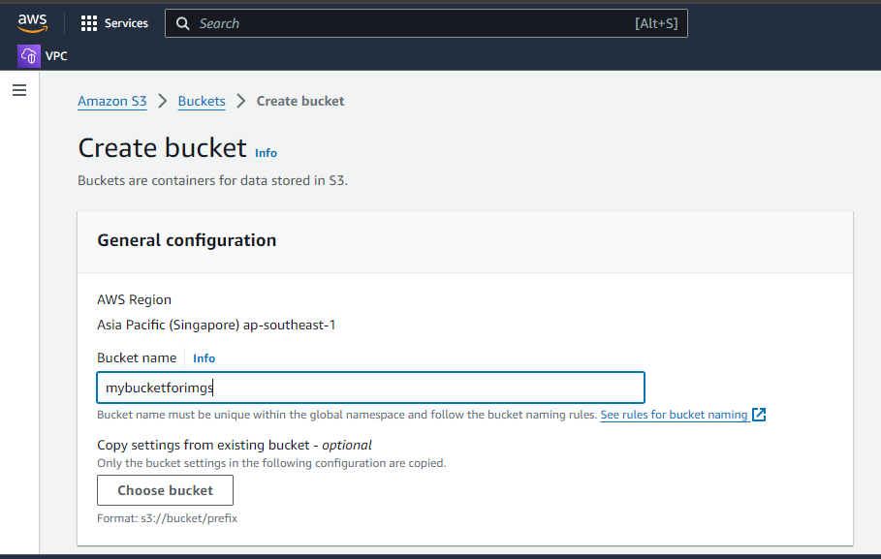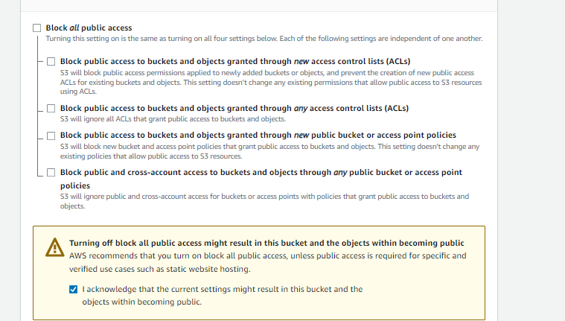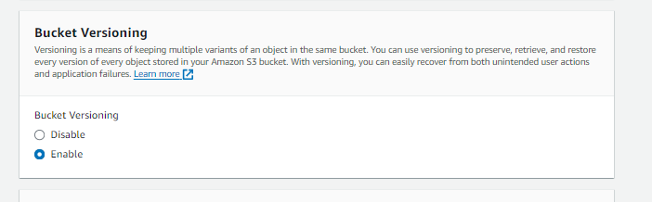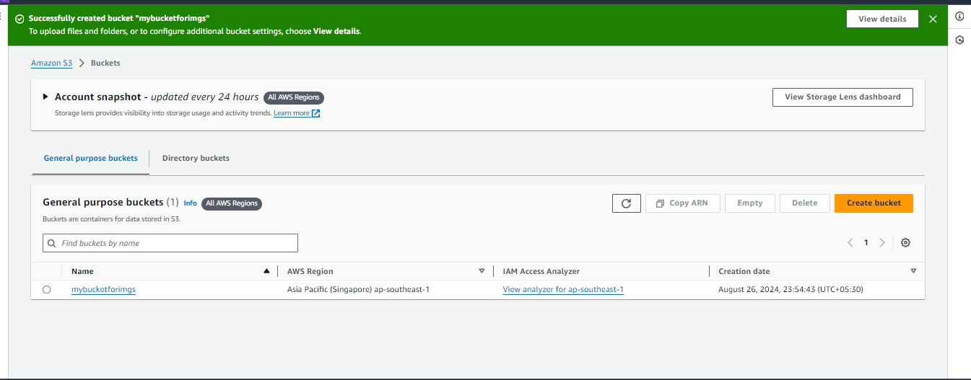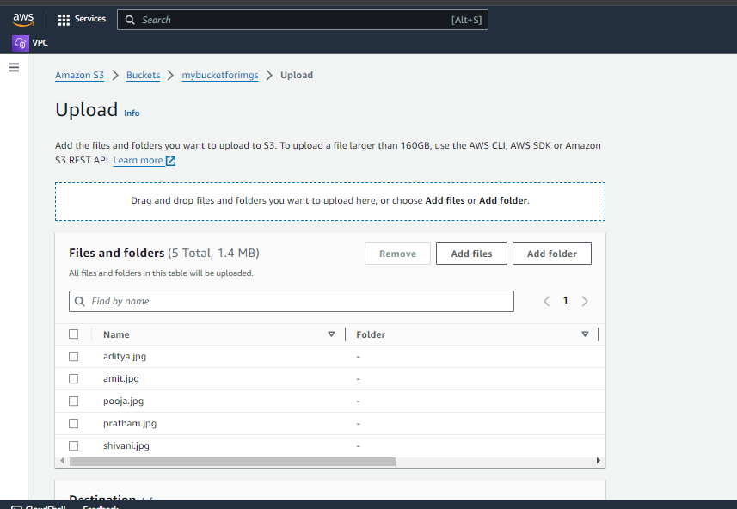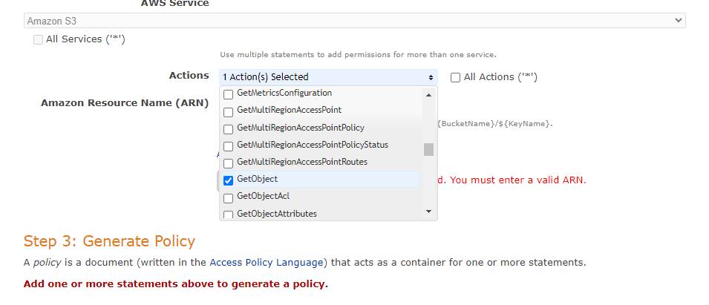

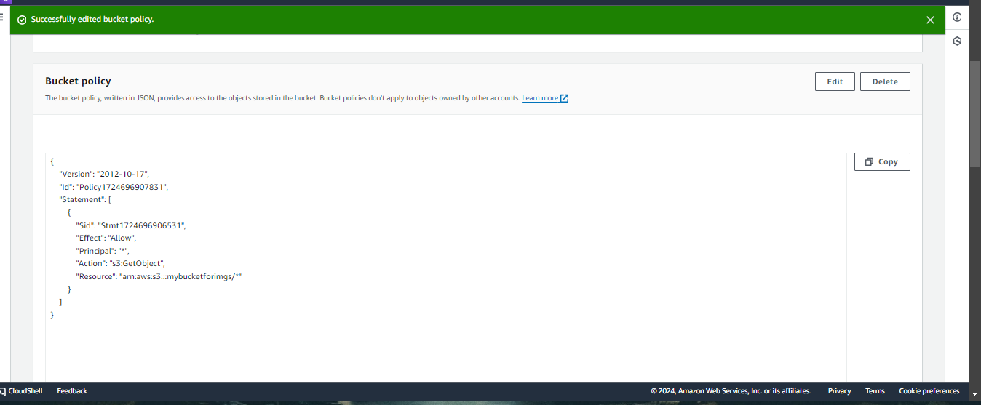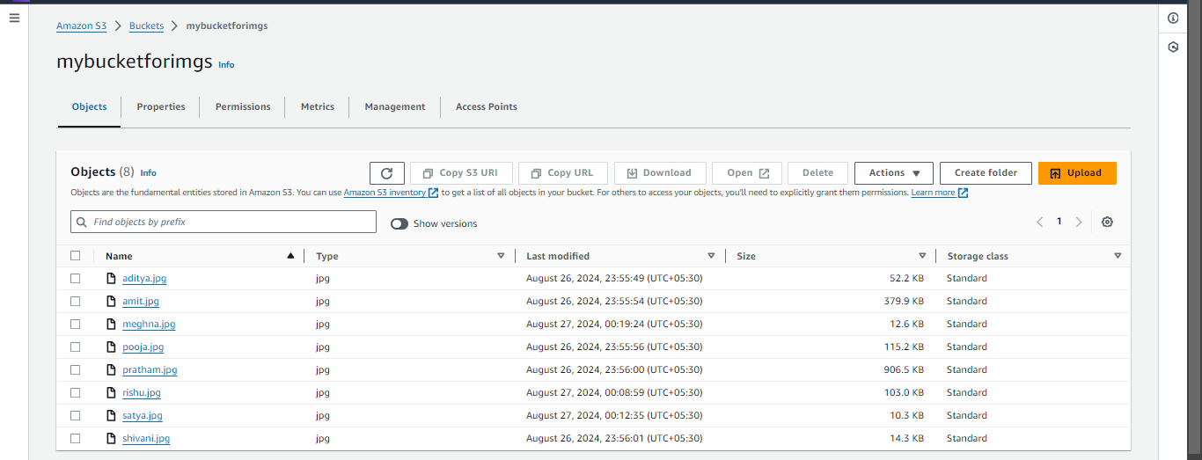

* Creating a image using dockerfile of the website

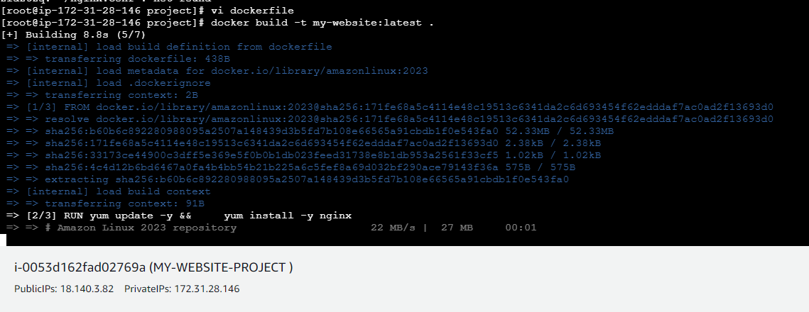

* **Creating the elastic container registry to store the image created by the dockerfile**

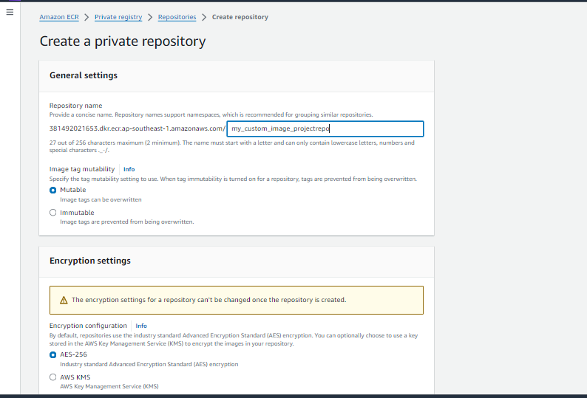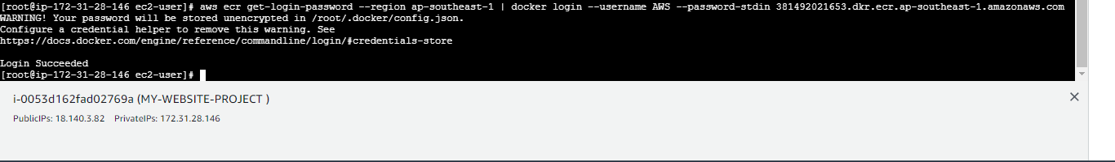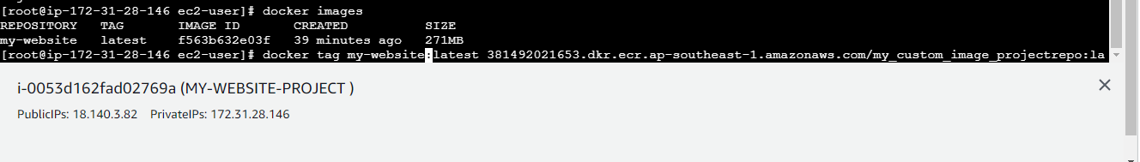

* Now creating cluster in elastic kubernetes service for creating the containers and running applications in the container

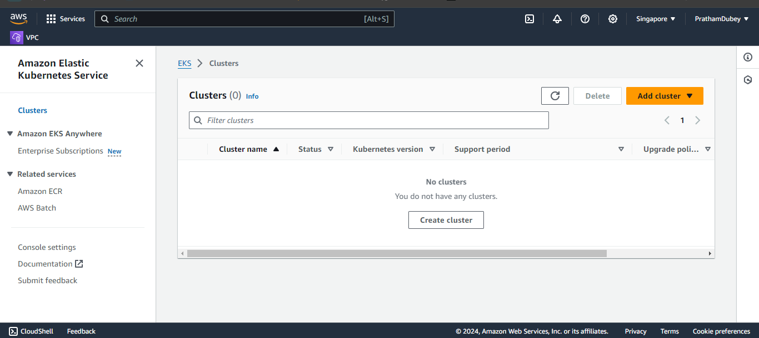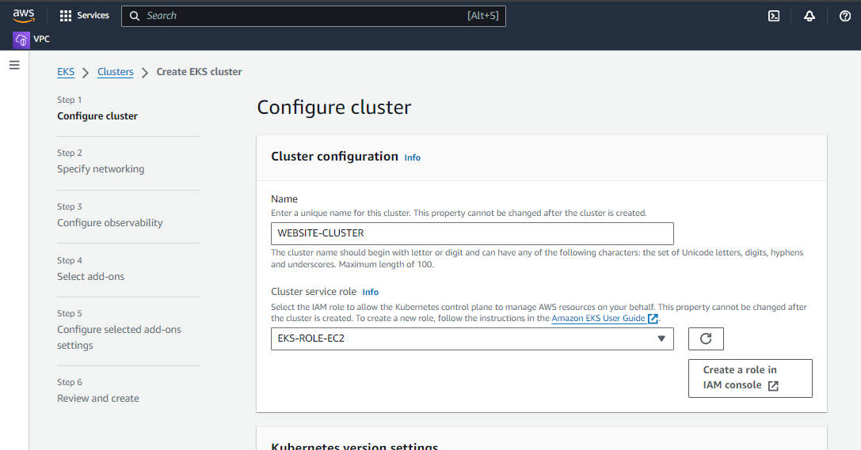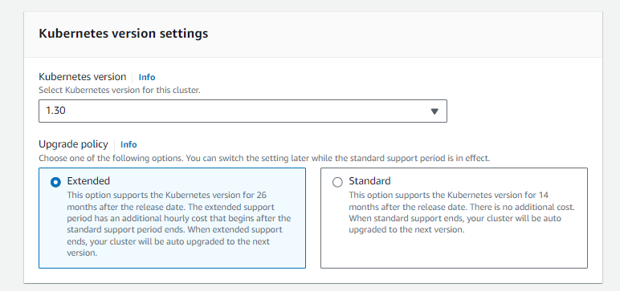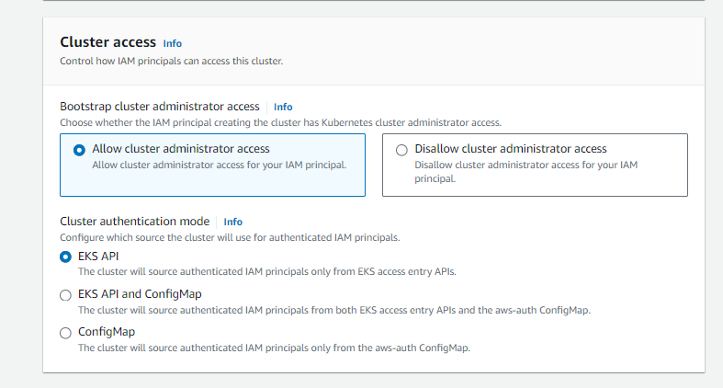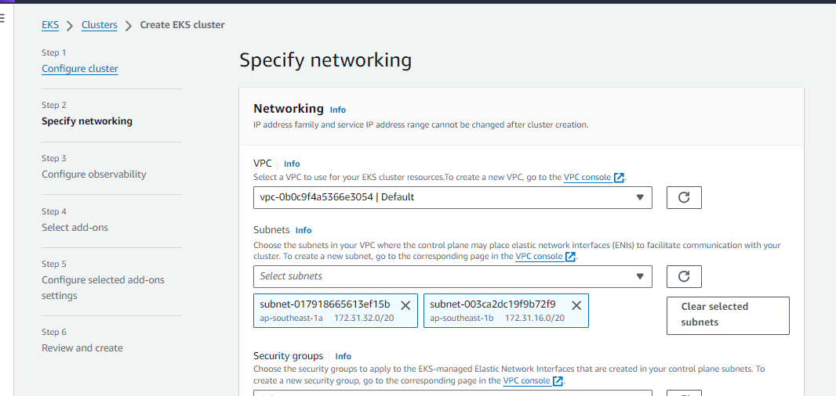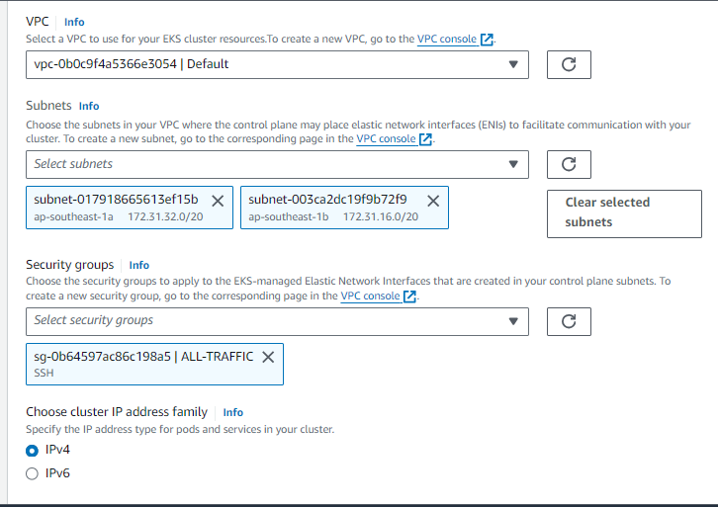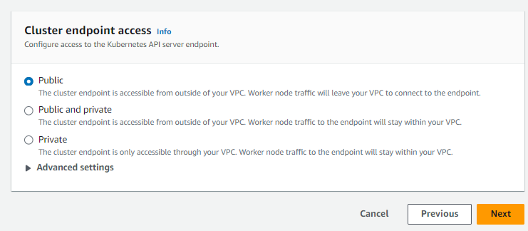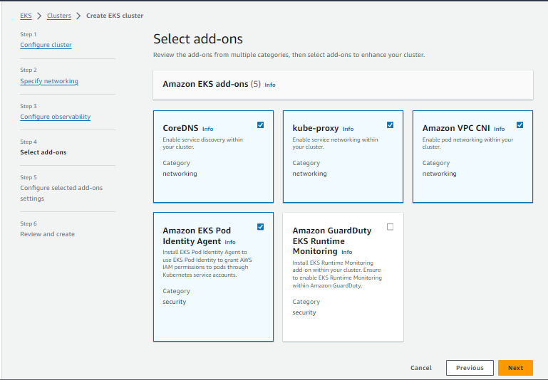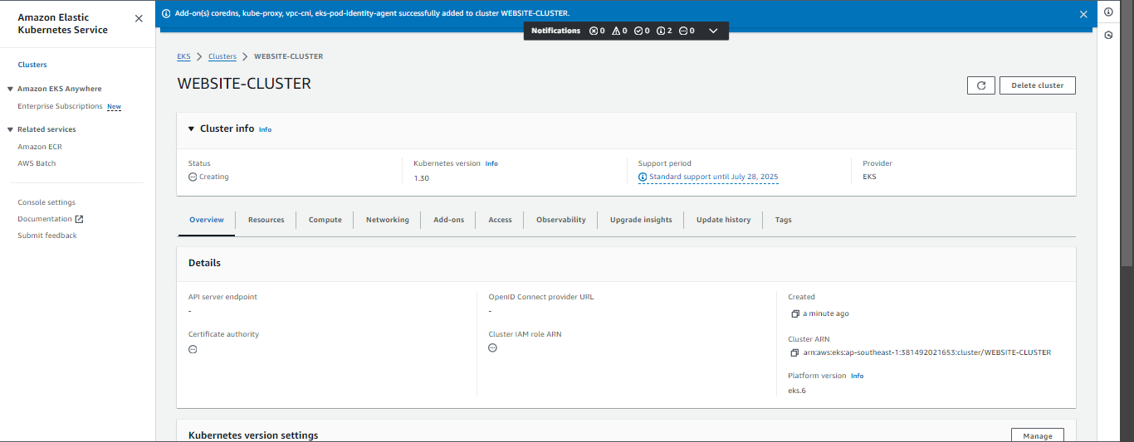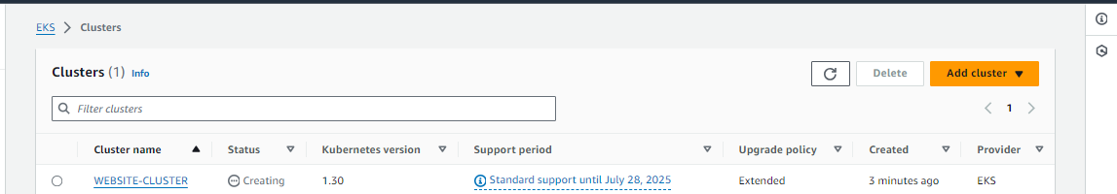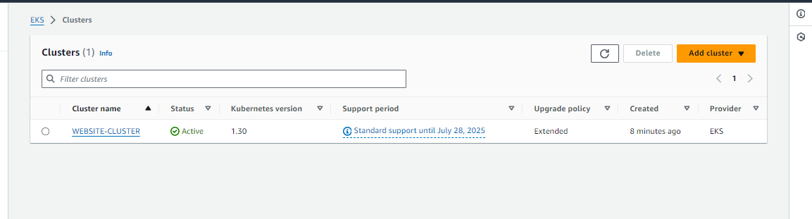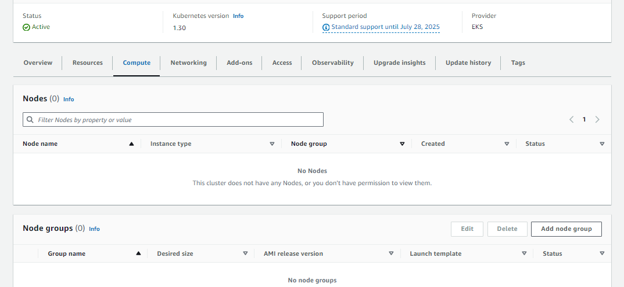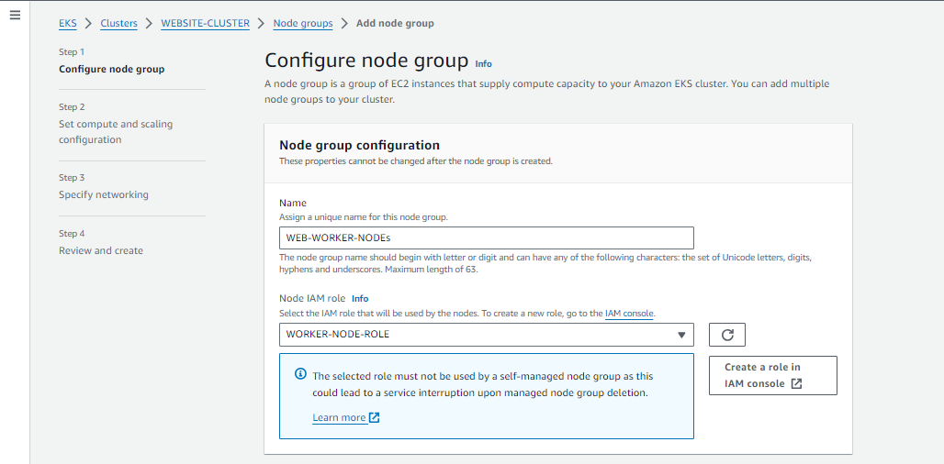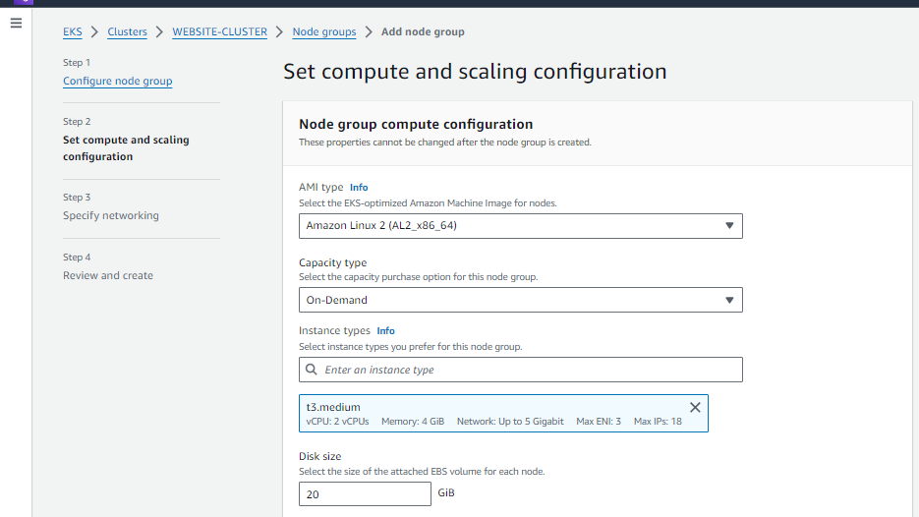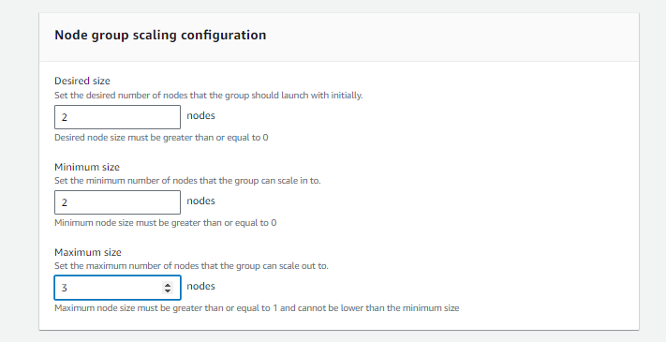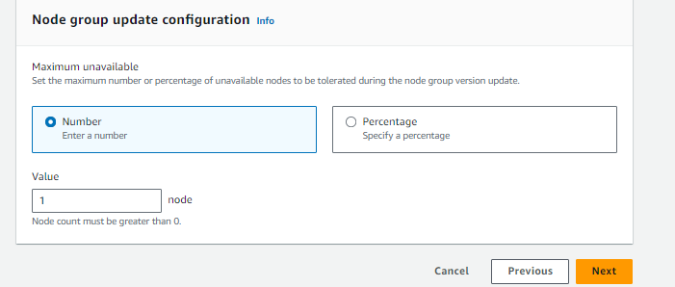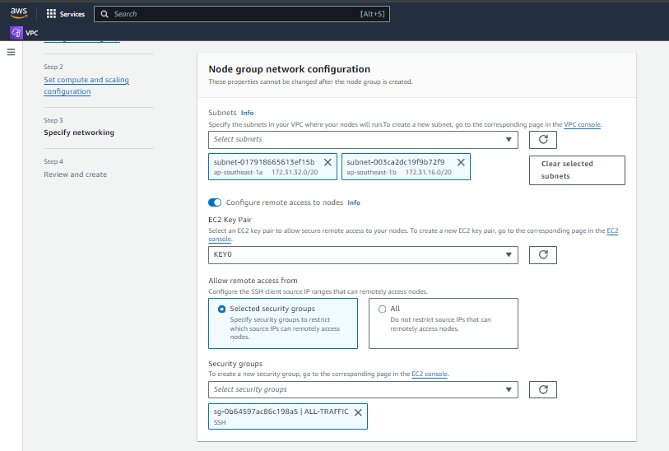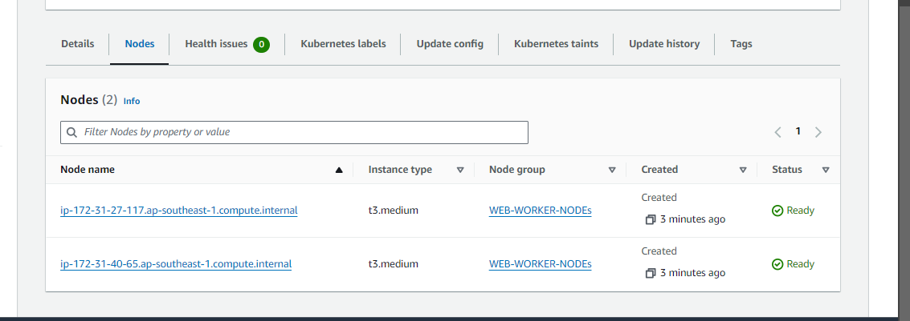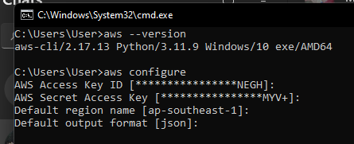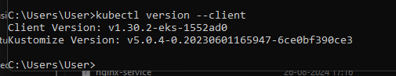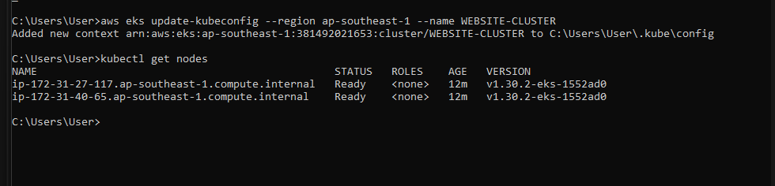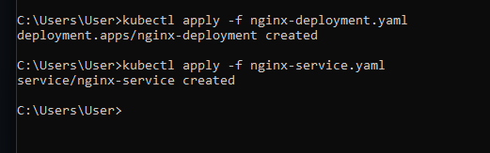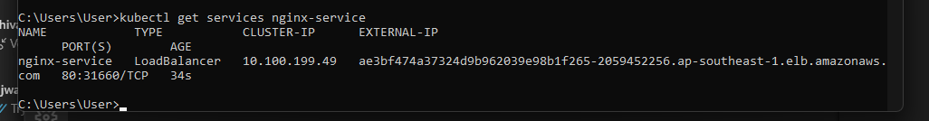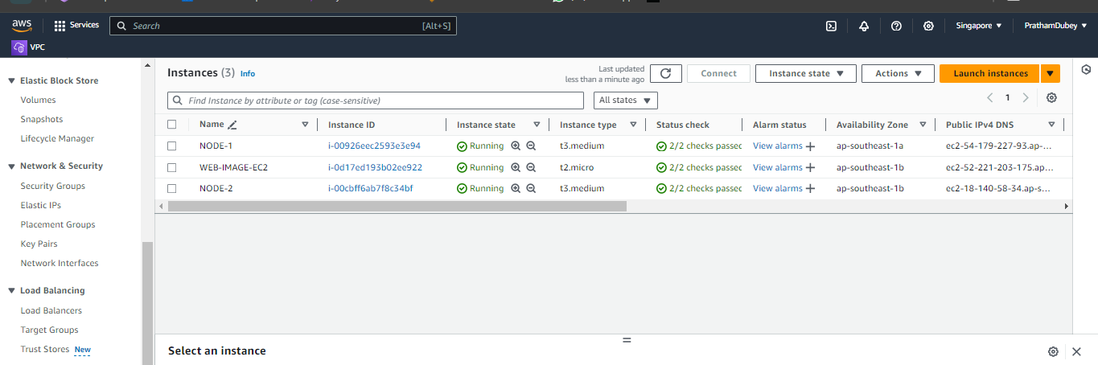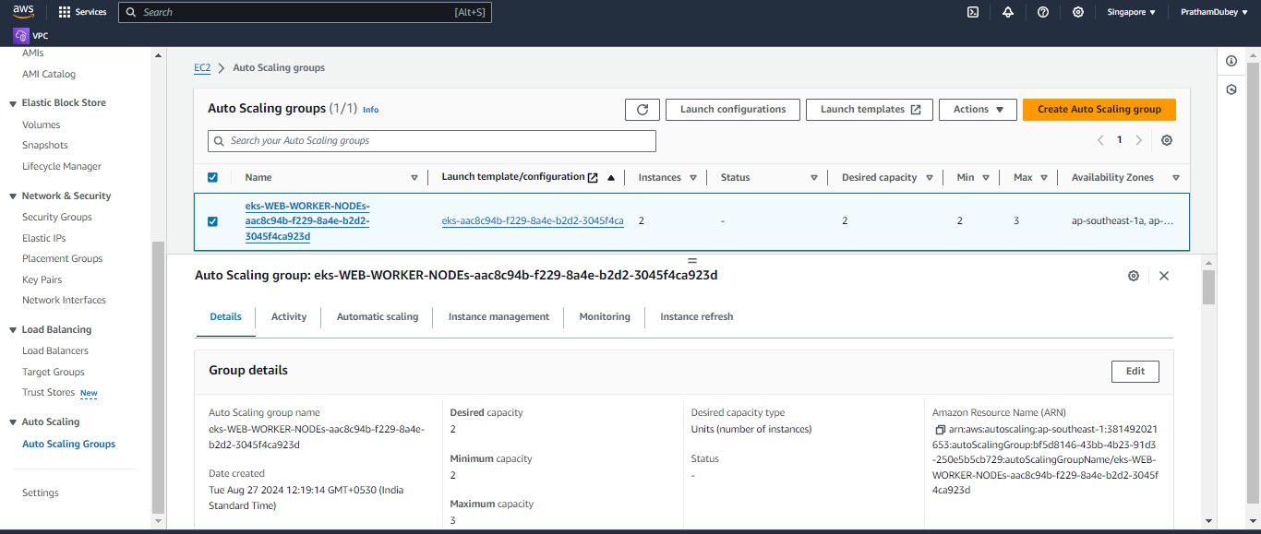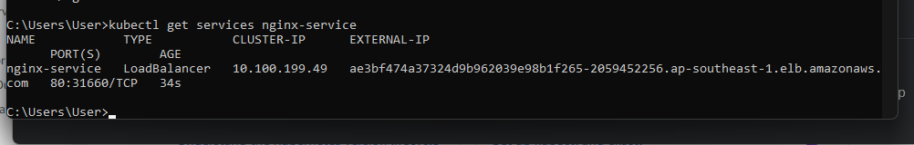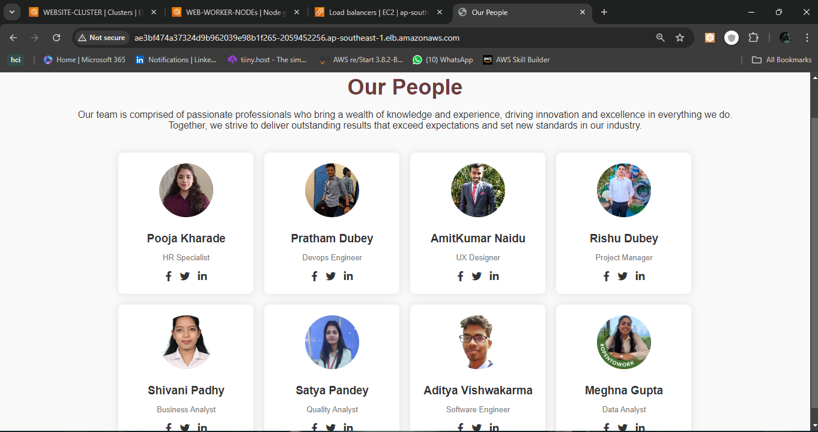

* Creating the new instance for deploying my own ecommerce website in the same way

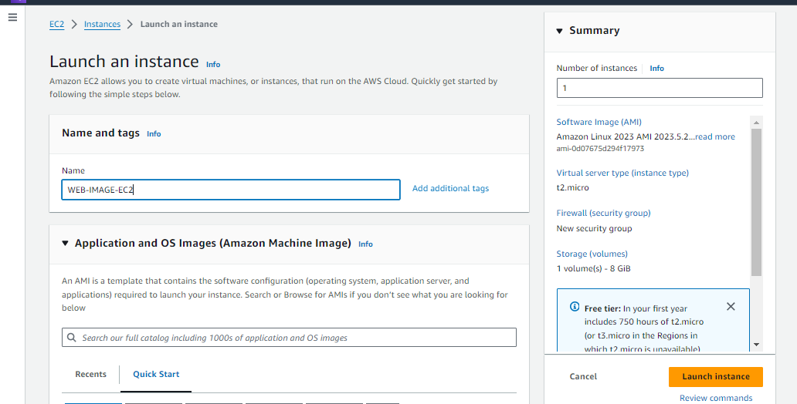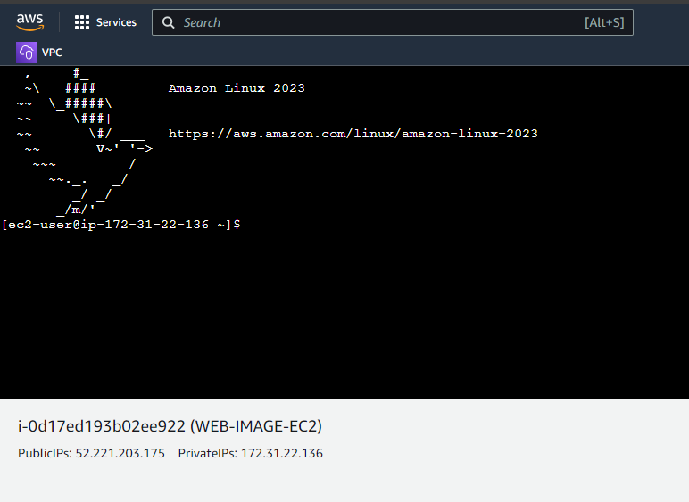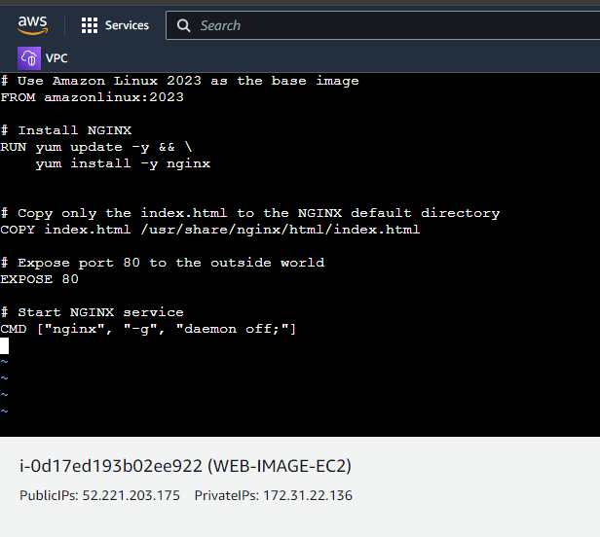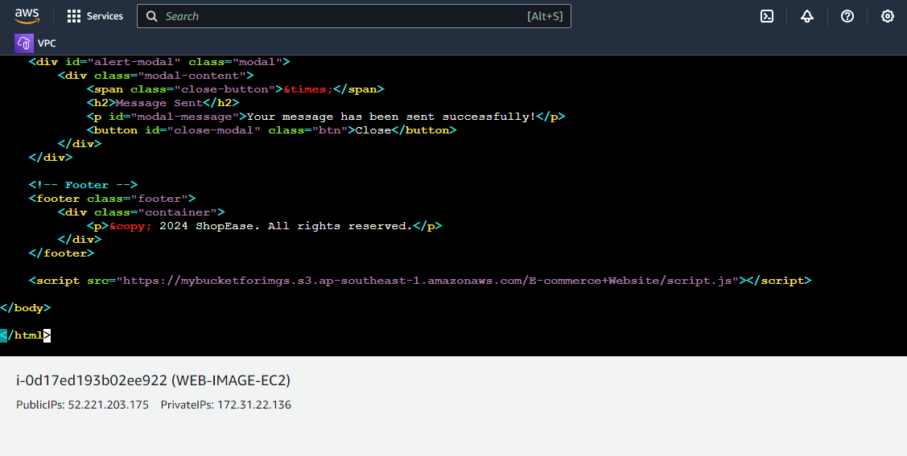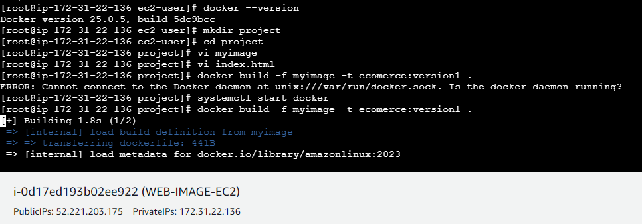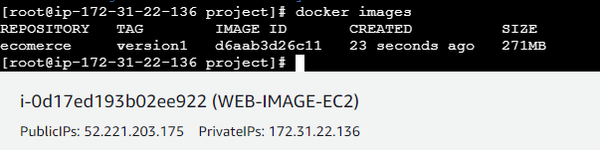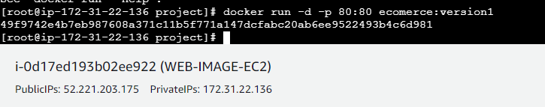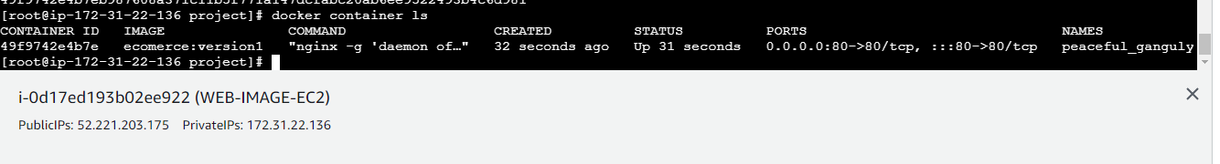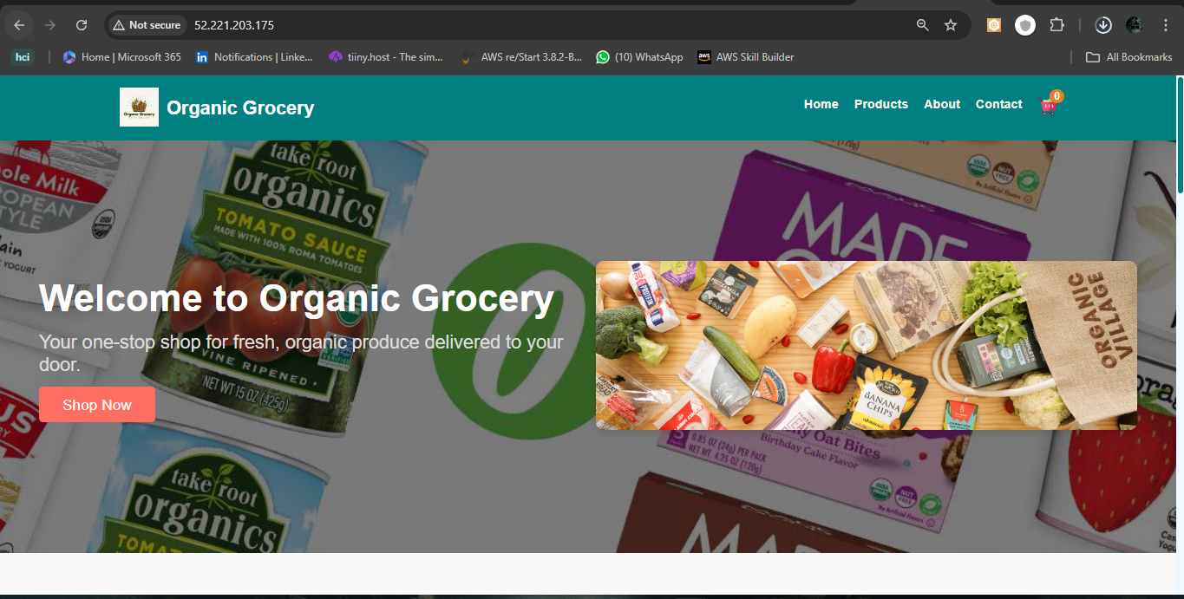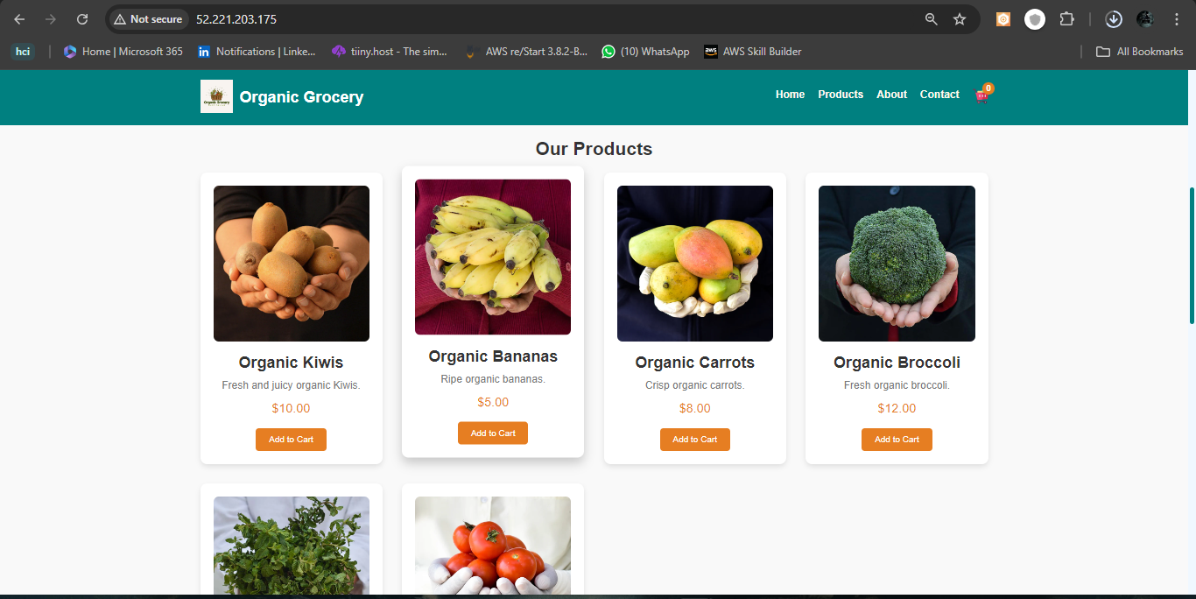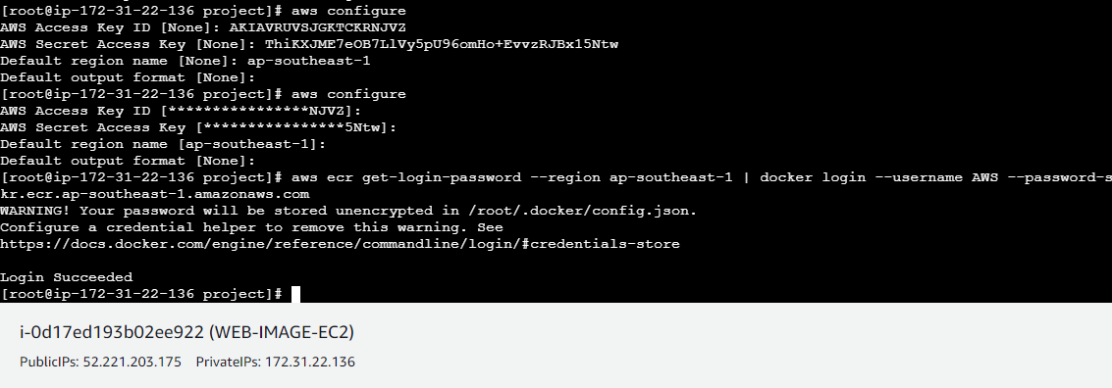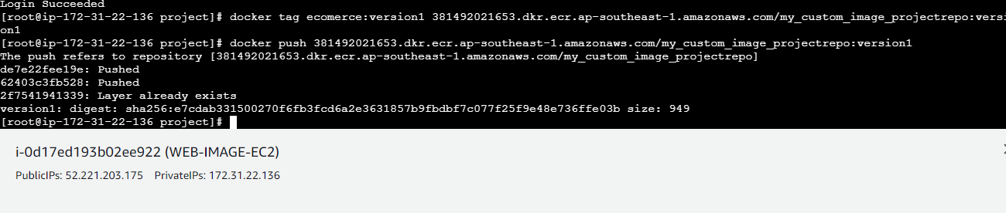

* push the image that you have created in the elastic container registry

